# AWS Server Migration Service (SMS)

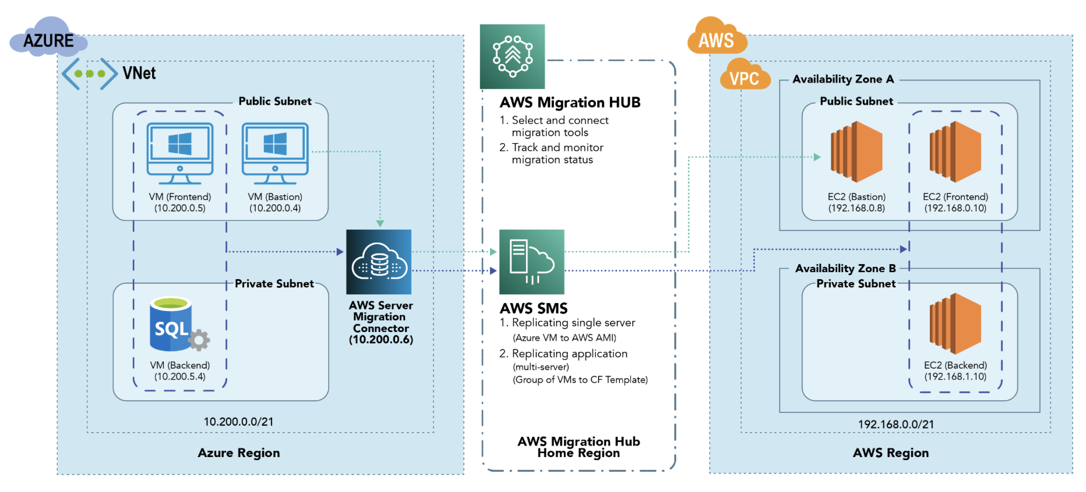

* AWS Server Migration Service (SMS) is a cloud-based service provided by Amazon Web Services (AWS) that facilitates the migration of on-premises servers to the AWS cloud. It enables organizations to automate, simplify, and accelerate the process of moving their existing servers and workloads to the AWS environment.
* The primary goal of AWS SMS is to streamline the migration process, making it faster, more efficient, and less error-prone, while minimizing downtime and disruptions to applications and services. The service achieves this by automating many of the manual tasks involved in server migration and providing tools for orchestrating the entire migration workflow.

# Table of Contents

1. Introduction to AWS Server Migration Service (SMS)

2. Key Concepts

2.1. Server Migration Connector

2.2. Server Migration Replication Job

2.3. Replication Settings

3. Supported Source and Target Platforms

4. Getting Started with AWS Server Migration Service

4.1. Prerequisites

4.2. Step-by-Step Migration Process

5. SMS Features and Benefits

5.1. Automated Server Discovery

5.2. Server Migration Scheduler

5.3. Application Migration

6. Monitoring and Troubleshooting

6.1. Viewing Replication Jobs

6.2. SMS Event Notifications

6.3. Troubleshooting Common Issues

7. Security and Compliance

7.1. Data Encryption

7.2. IAM Roles and Policies

7.3. Compliance Considerations

8. Best Practices for Server Migration with SMS

8.1. Preparing Source Servers

8.2. Target Environment Setup

8.3. Testing and Validation

9. Limitations and Considerations

9.1. Supported Regions and AWS Accounts

9.2. Unsupported Source Platforms

9.3. Disk and Volume Considerations

10. Conclusion

# 1. Introduction to AWS Server Migration Service (SMS)

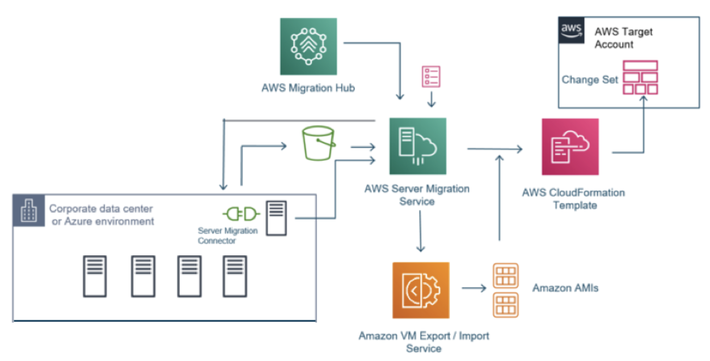

AWS Server Migration Service (SMS) is a cloud-based service that simplifies the process of migrating on-premises servers to AWS. It enables automated server discovery, replication, and orchestration of the migration process to make it faster and more efficient.

# 2. Key Concepts

**2.1. Server Migration Connector:**

The Server Migration Connector is a lightweight software installed on the source server that facilitates communication between the source and AWS SMS.

**2.2. Server Migration Replication Job:**

A Server Migration Replication Job defines the migration settings and orchestration for replicating the server data to the target environment.

**2.3. Replication Settings:**

Replication Settings include options such as replication frequency, bandwidth throttling, and data encryption during the migration process.

# 3. Supported Source and Target Platforms

AWS SMS supports a variety of source and target platforms, including VMware vSphere and Microsoft Hyper-V as source environments, and Amazon EC2 instances as target environments.

# 4. Getting Started with AWS Server Migration Service

**4.1. Prerequisites:**

Before using AWS SMS, ensure you have the necessary IAM permissions, installed Connector software, and network connectivity between the source and target environments.

**4.2. Step-by-Step Migration Process:**

A step-by-step guide to perform server migration using AWS SMS.

# 5. SMS Features and Benefits

**5.1. Automated Server Discovery:**

AWS SMS can automatically discover and catalog on-premises servers, making it easier to plan and execute migrations.

**5.2. Server Migration Scheduler:**

The Server Migration Scheduler allows you to control the migration process by setting schedules and defining migration priorities.

**5.3. Application Migration:**

AWS SMS enables you to migrate multi-tier applications as a cohesive unit, preserving application dependencies and configurations.

# 6. Monitoring and Troubleshooting

**6.1. Viewing Replication Jobs:**

Monitor and manage your replication jobs through the AWS Management Console or CLI.

**6.2. SMS Event Notifications:**

Set up event notifications to receive alerts about the migration progress and status.

**6.3. Troubleshooting Common Issues:**

Learn how to identify and troubleshoot common migration issues with AWS SMS.

# 7. Security and Compliance

**7.1. Data Encryption:**

Understand data encryption options available during the migration process.

**7.2. IAM Roles and Policies:**

Manage IAM roles and policies to control access to AWS SMS resources.

**7.3. Compliance Considerations:**

Considerations for maintaining compliance during the migration process.

# 8. Best Practices for Server Migration with SMS

**8.1. Preparing Source Servers:**

Best practices for preparing the source servers for migration.

**8.2. Target Environment Setup:**

Optimize the target environment to ensure a smooth migration process.

**8.3. Testing and Validation:**

Importance of testing and validation to ensure a successful migration.

# 9. Limitations and Considerations

**9.1. Supported Regions and AWS Accounts:**

Check the supported regions and AWS account considerations before using AWS SMS.

* Windows Server 2003, 2008, 2012, and 2016, and Windows 7, 8, and 10;
* Red Hat Enterprise Linux (RHEL), SUSE/SLES, CentOS, Ubuntu, Oracle Linux, Fedora, and Debian Linux operating system.

**9.2. Unsupported Source Platforms:**

Platforms that are not supported for migration with AWS SMS.

**9.3. Disk and Volume Considerations:**

Considerations for managing disks and volumes during migration.

# 10. Conclusion

Summarize the benefits of AWS Server Migration Service and encourage users to start their server migration journey.

For in-depth details and practical examples, refer to the official AWS SMS documentation: [AWS SMS Documentation](<https://docs.aws.amazon.com/server-migration-service/latest/userguide/>).

Thank you